**Ghulam Muhammad Lone**

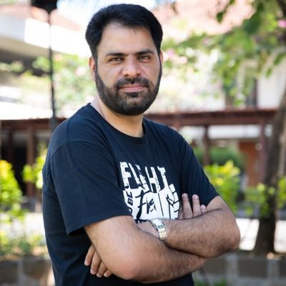

**About:** Ghulam Mohammad Lone, a freelance print reporter, who also wrote for the English newspaper Greater Kashmir. Lone, a newspaper salesman and freelance journalist who contributed to several publications. His seven-year-old son in their home in Kangan, Kashmir.

**Murdered on:** 29 August 1994

**Attack details:** A group of masked gunmen who also fatally shot his seven-year-old son in their home in Kangan, Kashmir.

**Reason to him target:** Lone had reportedly received death threats from a security agent for his coverage of troop movements in Kashmir.

**Occupation:** , A newspaper salesman and journalist.

**Belief:** Ghulam Mohammad Lone was a freelance print reporter.

**Link:** <https://cpj.org/data/people/ghulam-muhammad-lone/>

